
TEAL, Martin O'Neill 1
Draft: Teal Constitution
Proposal of a Self-Organization-Agreement of INI-ON-FIT-TSO-MFS

BASIS: Teal Constitution Workshop
This document is based on our joint efforts to work together at the "Teal Constitution Workshop".

Questions / Statements towards teal-organization
In the process of the workshop we gathered burning questions and statements towards/regarding teal-organization.
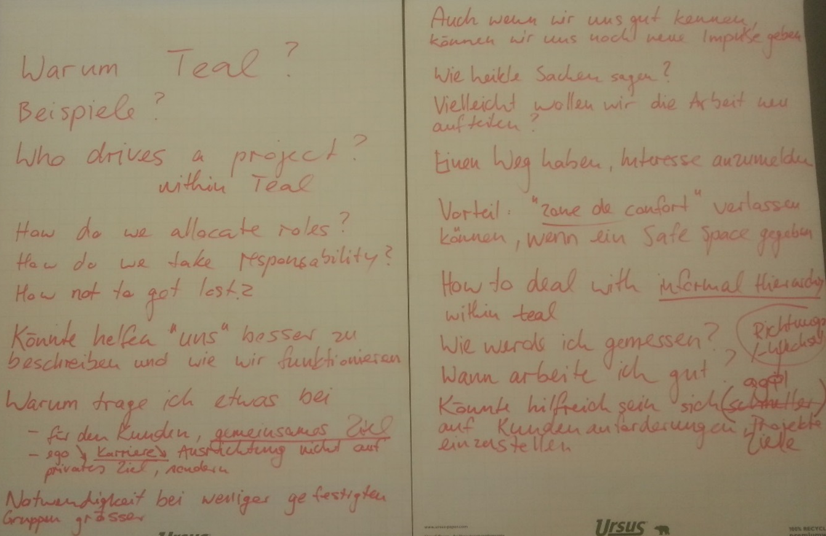

Warum Teal? | Beispiele?
Who drives a project within Teal? | How do we allocate roles?
How do we take responsibility? | How not to get lost?
Könnte helfen "uns" besser zu beschreiben und wie wir funktionieren. | Warum trage ich etwas bei?  - Für den Kunden, gemeinsames Ziel  - Weniger Ego, Karriere, Ausrichtung nicht auf privates Ziel, sondern gemeinsames
Notwendigkeit bei weniger gefestigten Gruppen grösser? | Auch wenn wir uns gut kennen, können wir uns noch neue Impulse geben.
Wie heikle Themen ansprechen? | Vielleicht wollen wir die Arbeit neu aufteilen?
Einen Weg haben, Interesse anzumelden. | Vorteil: "Zone de confort" verlassen können, wenn ein Safe Space gegeben ist.
How to deal with informal hierarchy within Teal? | Wie werde ich gemessen?
Wann arbeite ich gut? | Könnte hilfreich sein, sich schneller, agiler (in Bezug auf Richtungswechsel) auf Kundenanforderungen, Projekte, Ziele einzustellen.

Jointly developed priorities, guiding principles
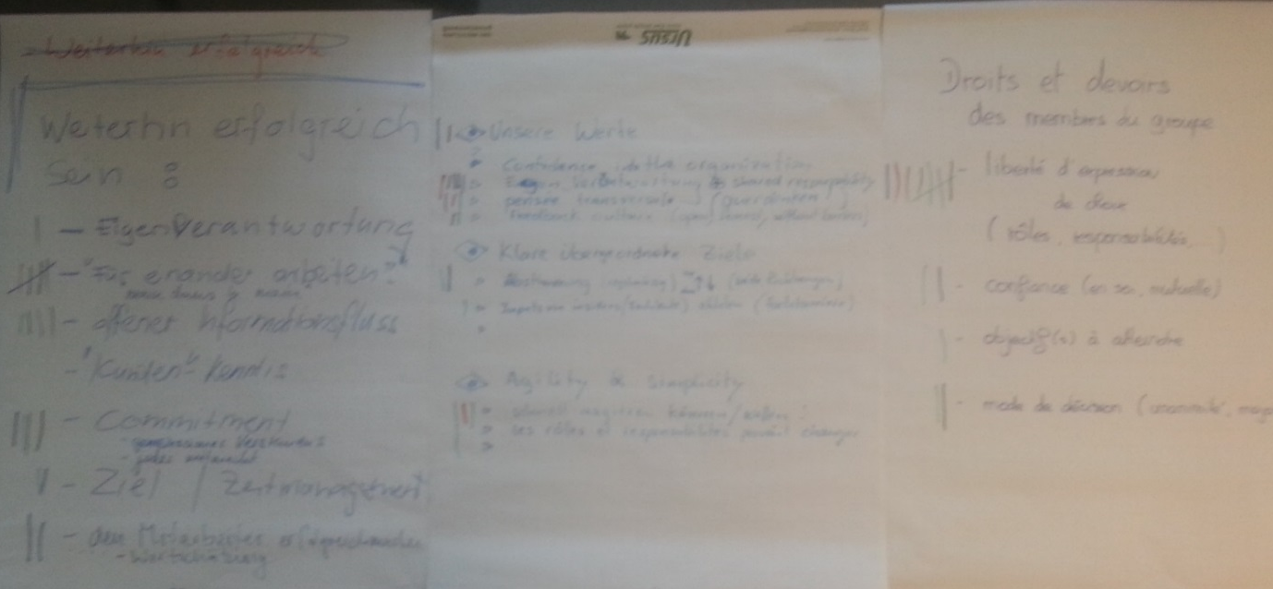

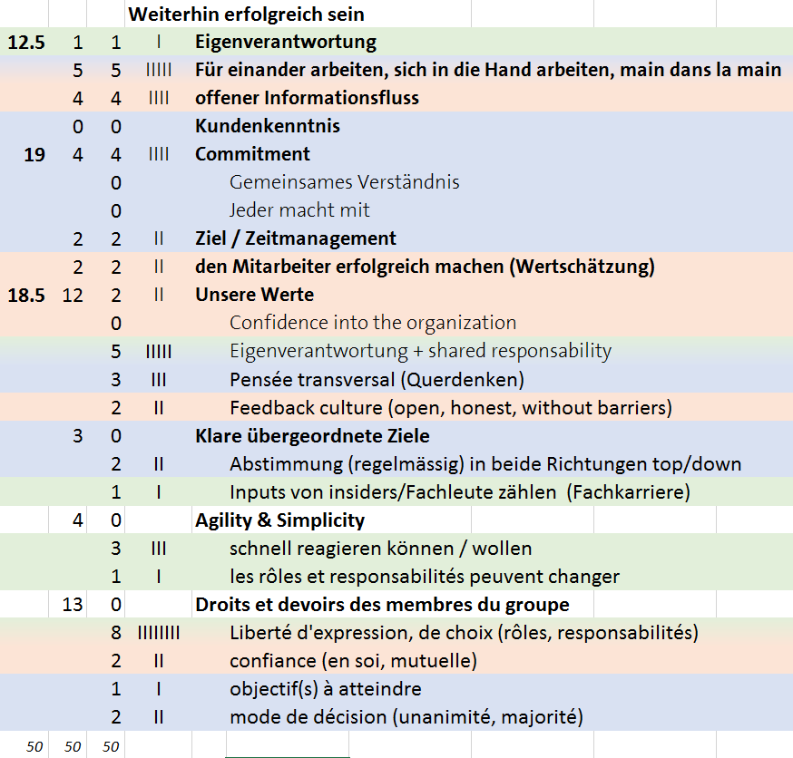

Preamble
This document reflects our wish to find our own way of working and our commitment and will to design our self-organization that it reflects our beliefs and findings on this path. We want to co-create our constitution or self-organization-agreement in a participative, responding manner over time, so it is a living document: the very heart of our self-governance.
What we all agree upon is, that we continue our successful collaboration! But which factors made us successful till now? We begin with a set of core themes we jointly put together at our constitution workshop, bundled and entitled as "Guiding Principles" in this document - well knowing that we could be missing even the most important things so far. Those themes are loosely coupled and seen in the light of the fundamental characteristics of teal organizations described in the appendix: "Self-Management, Wholeness and Evolutionary Purpose".

Guiding Principles

Core Values

Confidence / Trust
When we're surrounded by people who believe what we believe, something remarkable happens… Trust emerges. [Simon Sinek]
Self-Confidence
We take the freedom to find our own professional way of doing meaningful work.
We let go of any order receiving attitude and try not to get carried away by command demanding behavior.
Mutual Confidence
We respect and honor our partners professional way of working.
We let go of commanding and controlling habits, especially at the micro-level.

Appreciation / Estimation
Feedback Culture
We take open, honest feedback as a token of esteem. We try to listen as much as we can to the underlying arguments.
Open flow of information
We share information inclusively.
We open up barriers and don't hold back, appreciating thoughts coming from outside of the box.
Self-efficacy is delight
We want to make our colleagues successful, therefore we appreciate our partners by letting them act effectively and supporting them.

Commitment

Collaborative Spirit
Hand in Hand
We work together, both asking for and giving advice. Only advice, not commands.
We take responsibility for tasks in our domain that are crucial for our partners and customers.
Manage Criticism
Any product produced by any individual or individuals, belongs to the group, therefore any criticism of the product should not be taken personally. The product is being constructively criticized, not the person or persons who produced it. This helps in the acceptance of criticism.

Creating Common Understanding
Coordinate Goals and Objectives
We regularly coordinate overall objectives in both directions: top down and bottom up.
We are aware of the limits of our freedom: We decide what limits we will try to push and where we want to promote our view.
We create interfaces to buffer, interpret and translate imposed roles and objectives.

Coordinating Domains, Projects and Information
We coordinate who is in charge of what domain.
We generally commit to roles in the form of a statement or declaration of what can be expected from you, how you understand your role. Example: Morning Star™ uses the "Colleague Letter of Understanding (CLOU)". Other ideas: Statement of Understanding (SOU), Declaration on what to EXpect(DEX), COmittement to Roles and what can be Expected (CORE)…
We try to find common ground as to what is important to the group with regard to the work to be done, both in the long and short term.
We define which information is important and where it is stored and how it is made findable.
We define which communication channel is suited, depending on the level of importance of the information.
Decision Mode
We respect the decisions taken in any domain, provided that advice was taken into account. However, the decision taker is under no obligation to follow the advice.
We generally prefer action over perfection. We want to think big, act small, fail fast and learn rapidly.
We choose different decision modes according to the perceived complexity of the matter in question.

Self- & Shared Responsibility
Self-Responsibility
We take responsibility in our domain. We hold ourselves accountable with our commitment to roles declaration or statement (e.g. CLOU, SOU, DEX, CORE).
We act highly autonomous, but we adhere to the advice process. This means, when our decisions are likely to affect others, we ask for advice from those affected and we take into account the opinion of professionals, but we are free to reject the advice.
We reach for help, when workload gets too heavy or any other tension occurs and address it in group.
We are free to take different tasks and roles we wish to fulfil, when we seek advice and hold ourselves accountable.
Shared Responsibility
We hold partners accountable to their commitment in role and so we give feedback as it is needed. Additionally, we give annual feedback to our direct partners (e.g. CLOU, SOU, DEX, CORE) commitment fulfilment (replaces performance dialog).
We hold partners accountable to their adherence to the advice process.
We offer help when we perceive that someone's workload is too heavy and address it in group.
We address undermining behaviour to our self-organization-agreement, especially the advice process must be held dear and must therefore be protected.
We discuss perceived tendencies of command and control behaviour.
We discuss using rational arguments rather than argue over opinions. We constructively criticize the work done or incident occurring, not the person or persons who produced it.
To make it easier to accept criticism we exercise tactful criticism: "It happened to A that X broke", instead of "A broke X", and see individual's work as the group's product.

Appendix

Fundamental characteristics of Teal organizations
Quelle: Presentation: Teal Organizations (brief)

Self-Management
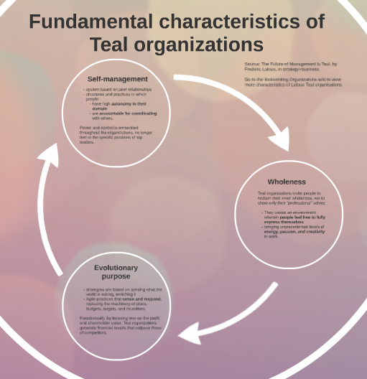
Teal organisations operate effectively, even at a large scale, with a system based on peer relationships. They set up structures and practices in which people have high autonomy in their domain, and are accountable for coordinating with others. Power and control are deeply embedded throughout the organizations, no longer tied to the specific positions of a few top leaders.

Wholeness
Whereas Orange and Green organisations encourage people to show only their narrow “professional” selves, Teal organisations invite people to reclaim their inner wholeness. They create an environment wherein people feel free to fully express themselves, bringing unprecedented levels of energy, passion, and creativity to work.

Evolutionary Purpose
Teal organisations base their strategies on what they sense the world is asking from them. Agile practices that sense and respond replace the machinery of plans, budgets, targets, and incentives. Paradoxically, by focusing less on the bottom line and shareholder value, they generate financial results that outpace those of competitors.

Self-governance & Advice process

